**USER MANUAL**

**This Is A User Manual for The Website of Universal Stationery Which Was Made by The Students of Aptech For the Purpose of**

**E-Project**.



**GROUP MEMBERS**

“Syed Muhammad Danish, Student: 1340587”

“Muhammad Hamza Sohail, Student: 1340542”

“Muhammad Ahsan, Student: 1343003”

**FACULTY :** AATIKA LIAQUAT

**BATCH CODE : 2110C1**

**CURRICULUM : 6672**

**HOME PAGE**

**In start you will see a Logo & header Image.**

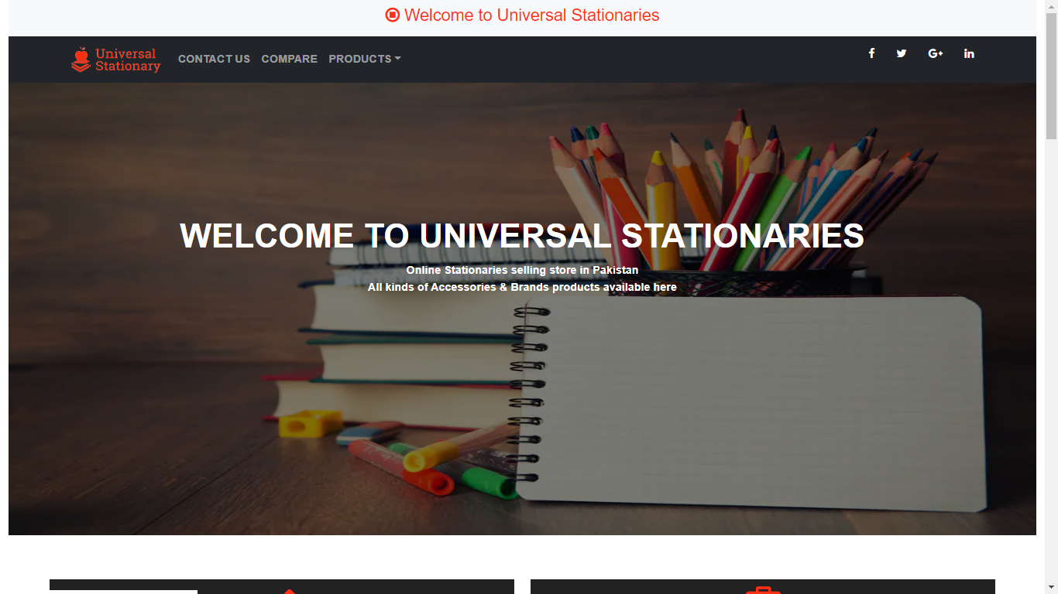

**Then index page shows the Top Categories of the site.**

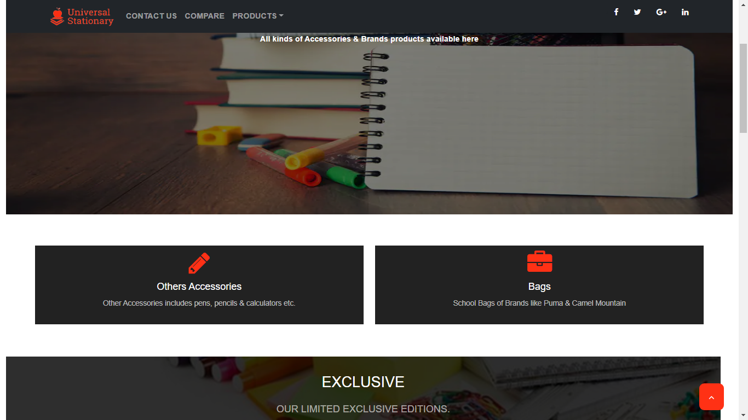

**Then index page shows the Exclusive of the site.**



**Then index page shows the Best Sellers & Brand Logos of the site.**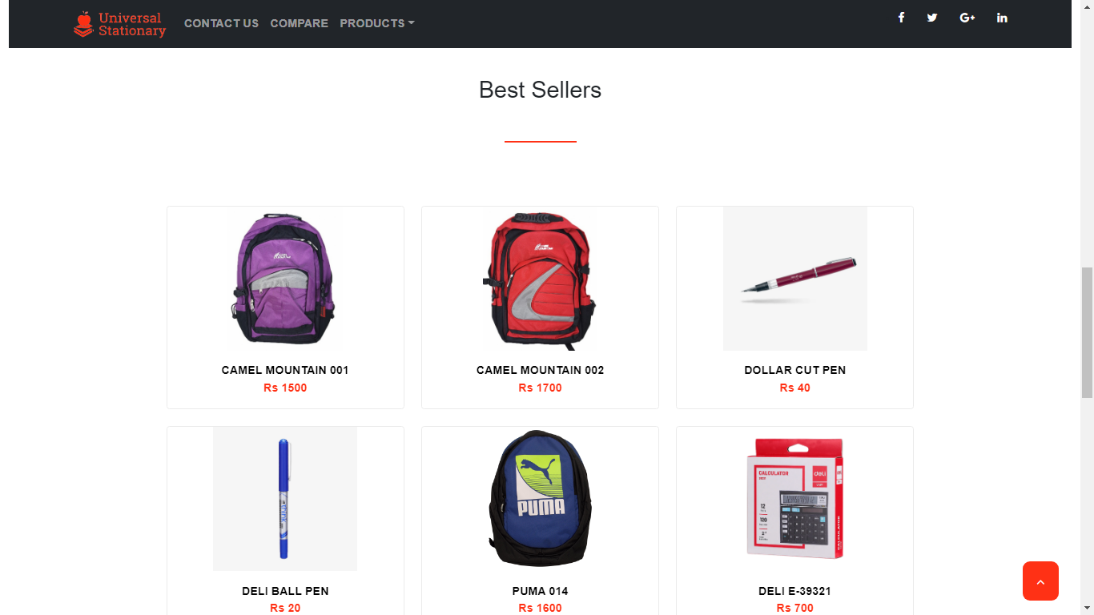

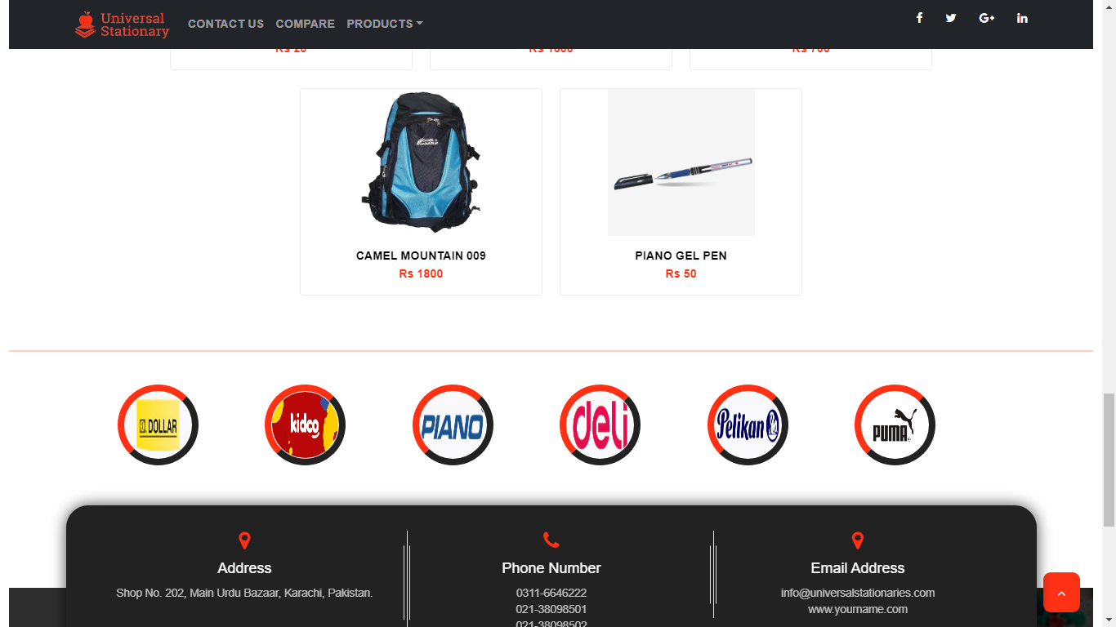

**Then index page shows the Contact Address & Footer of the site at the bottom.**

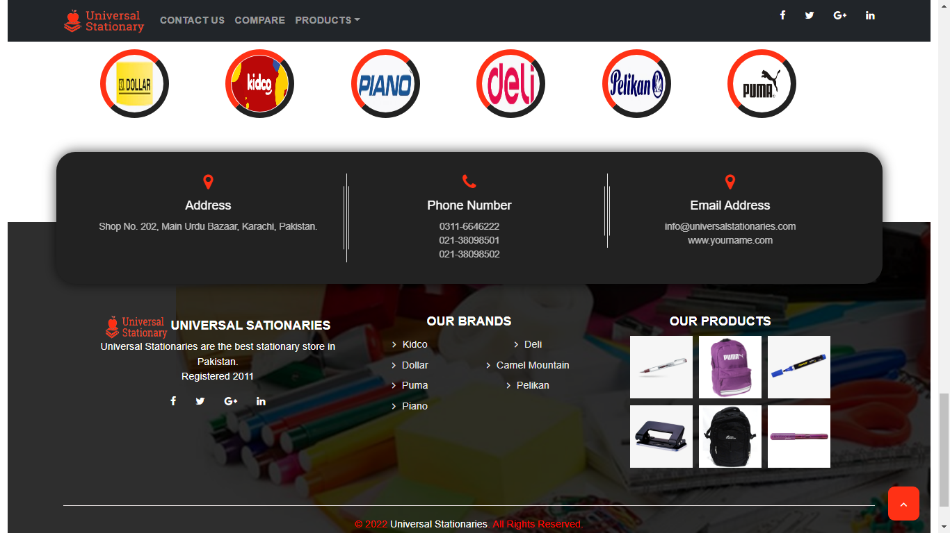

**Then shows Contact Page, There Is Location Marked on The Map and Our Contact Us Details**

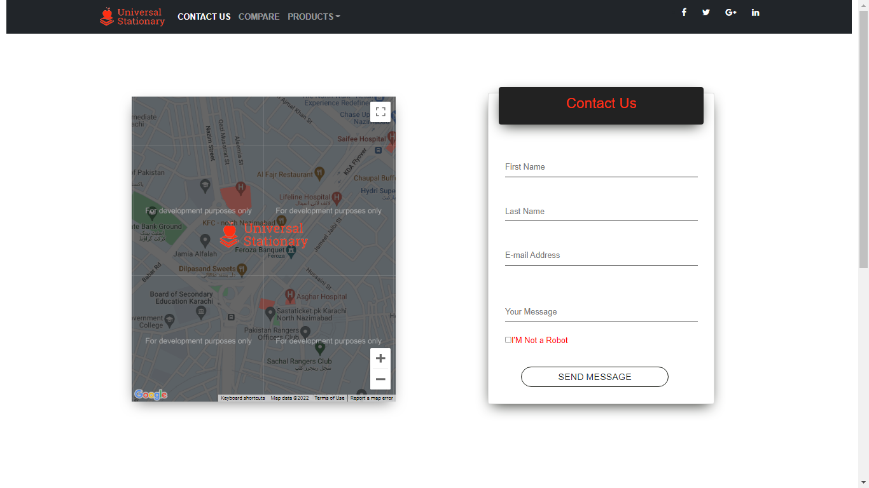

**Then shows Compare Page, The is product to product comparison.**



